University Of Engineering and Technology, Lahore
Computer Engineering Department

Course Name: Programming Fundamentals | Course Code: CMPE-112L
Assignment Type: Lab Tasks | Dated: 18-05-2026
Semester: 1st | Session: Spring
Lab/Project/Assignment #: 10 | CLOs to be covered: CLO 2
Lab Title: Recursion | Teacher Name: Hafiz Muhammad Mubashar
Lab Evaluation:

CLO1 | Apply appropriate programming techniques to create executable programs to solve well defined problems
 | Level1 | Level2 | Level3 | Level4 | Level5 | Level6
(5)
Total |  |  |  |  |  | /5
Rubrics for Current Lab Evaluation
Scale | Marks | Level | Rubric
Excellent | 5 | L1 | Submitted all lab tasks, BONUS task, have good understanding.
Very Good | 4 | L2 | Submitted the lab tasks but have good understanding
Good | 3 | L3 | Submitted the lab tasks but have weak understanding.
Basic | 2 | L4 | Submitted the lab tasks but have no understanding.
Barely Acceptable | 1 | L5 | Submitted only one lab task.
Not Acceptable | 0 | L6 | Did not attempt
LAB No 1
Lab Goals/Objectives:
To understand recursion in Python and solve different problems using recursive functions.
Equipment Required:
Computer or Laptop, Python 3.x, PyCharm or VS Code.
Theory:
Recursion is a programming technique in which a function calls itself until a base condition is reached. It is commonly used for mathematical calculations, searching, and string operations.

Lab Work:
Task 1: Calculate the factorial of a number using recursion.
Result:
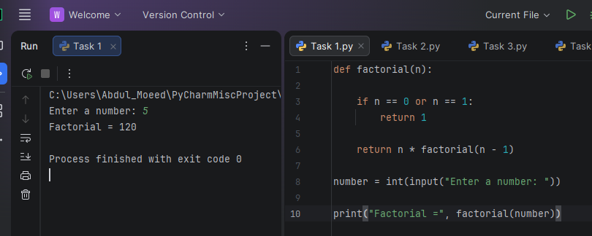

Task 2: Generate the Fibonacci series using recursion.
Result: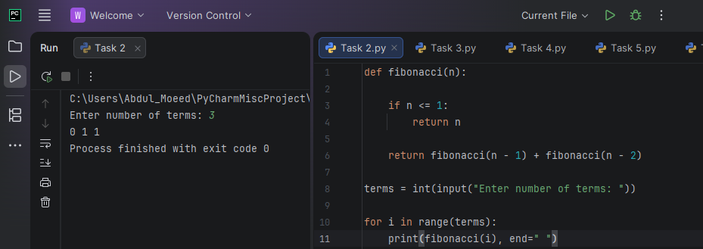

Task 3: Find the sum of natural numbers using recursion.
Result:
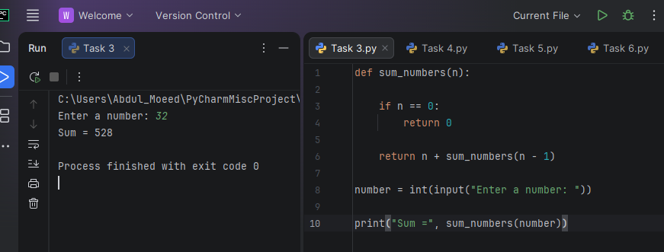

Task 4: Reverse a string using recursion.
Result:
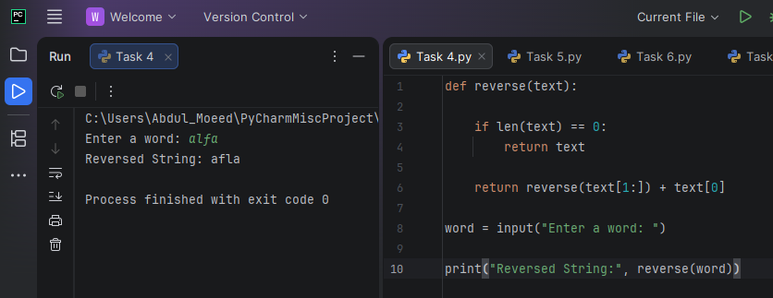

Task 5: Calculate the power of a number using recursion.
Result:
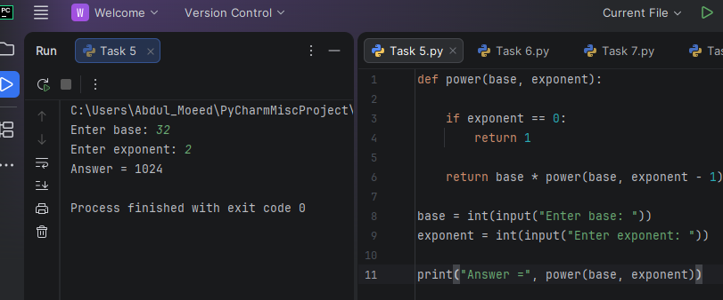

Task 6: Count the digits of a number using recursion.
Result:

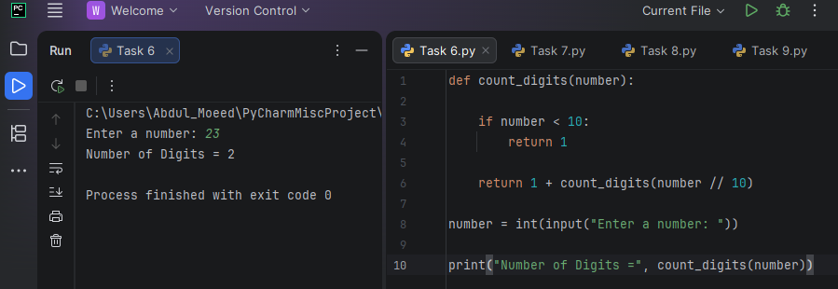

Task 7: Find the GCD of two numbers using recursion.
Result:
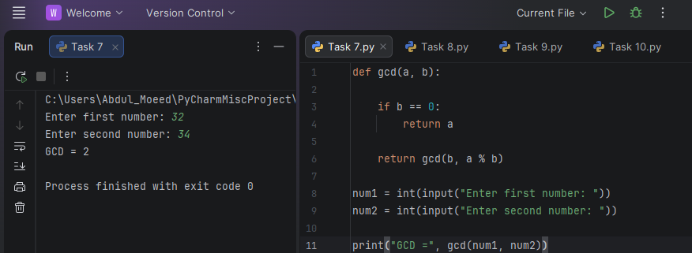

Task 8: Convert a decimal number to binary using recursion.
Result: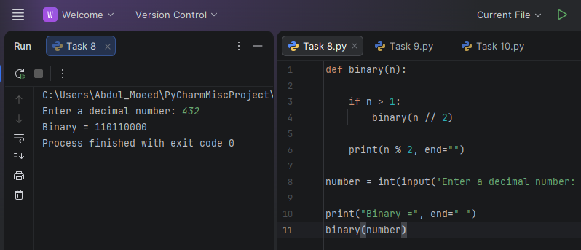

Task 9: Check whether a string is a palindrome using recursion.
Result:

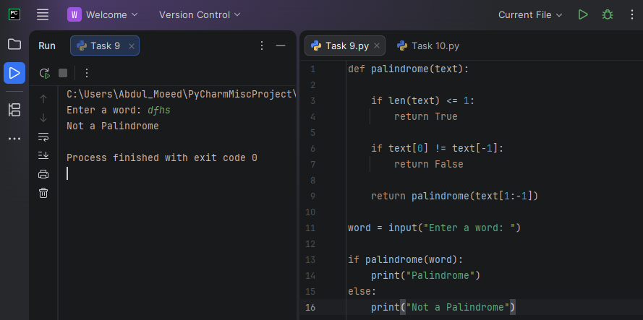

Task 10: Find the largest element in a list using recursion.
Result:

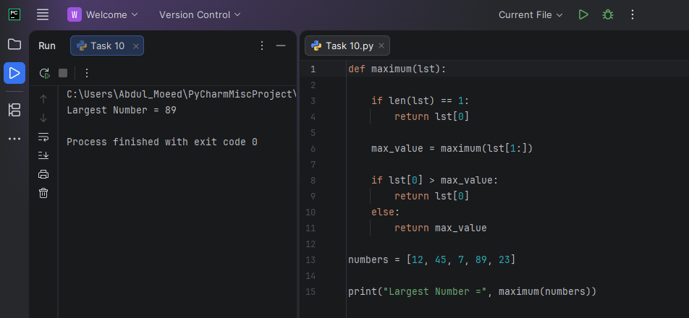

Conclusion:
The lab improved understanding of recursive functions and their use in solving mathematical, string, and list-based problems.

